**Lab 9**

**1. Write a Python program to Count all letters, digits, and special symbols from the given string. Input = “P@#yn26at^&i5ve”**

**Output: Chars = 8 Digits = 2 Symbol = 3**

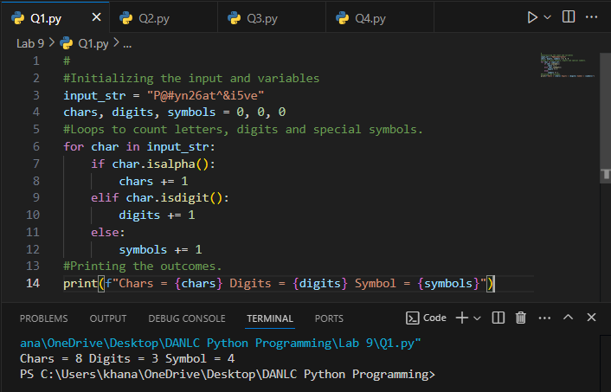

**2. Write a Python program to remove duplicate characters of a given string. Input = “String and String Function”**

**Output: String and Function**

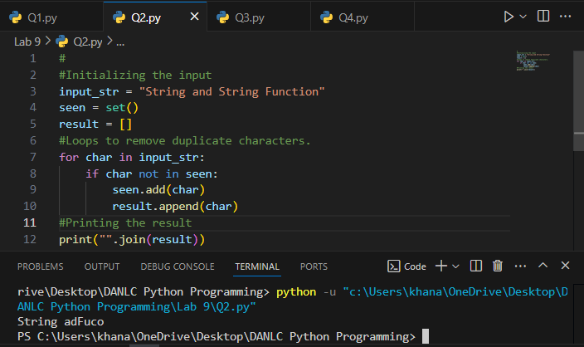

**3. Write a Python program to count Uppercase, Lowercase, special character and numeric values in a given string. Input = “Hell0 W0rld ! 123 * # welcome to pYtHoN”. Output: UpperCase : 5, LowerCase : 18, NumberCase : 5, SpecialCase : 11**

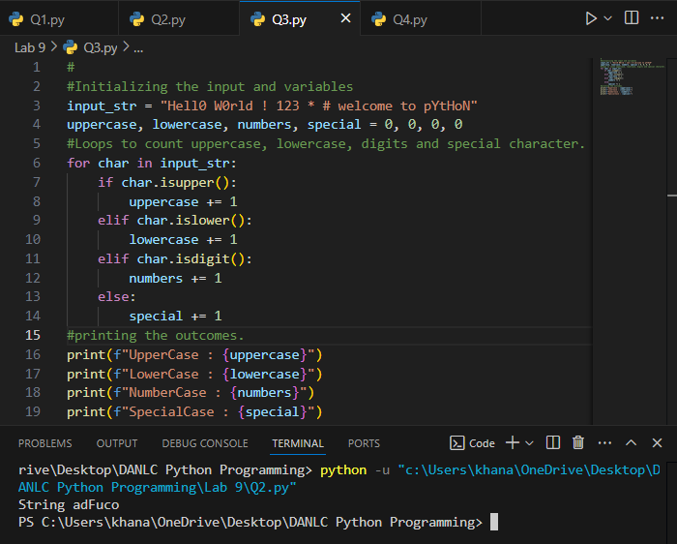

**4. Write a Python Count vowels in a string. Input= “Welcome to Python Assignment”. Output: Total vowels are: 8**

